Ujian Akhir Semester Pemrograman Berorientasi Object

Study case: Nasabah Bank

NIM​: 2412510030
Nama​: Nurul Silpia

Create Form – Blank Form
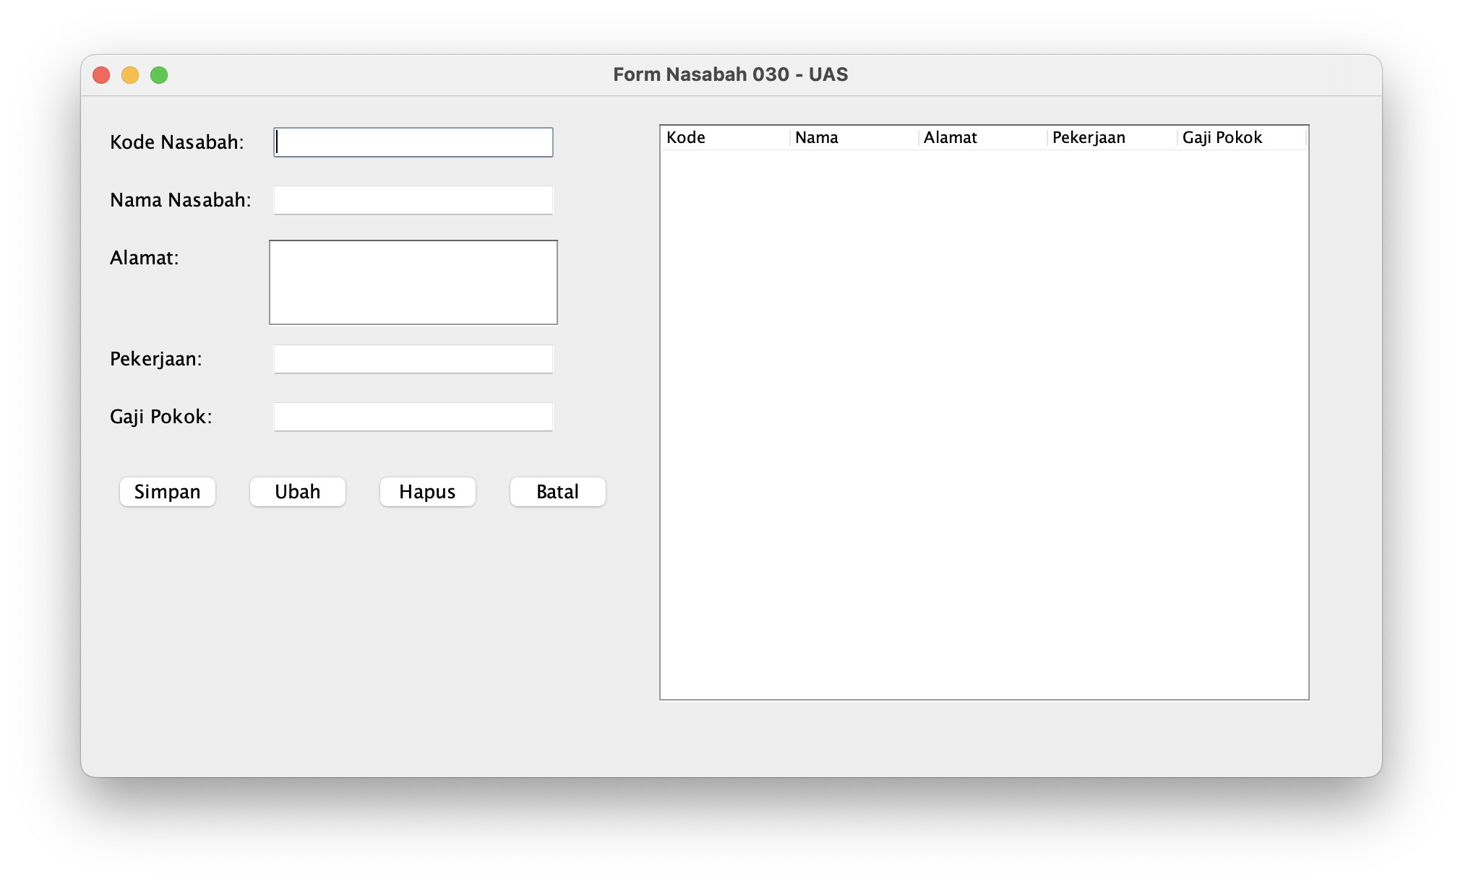

Create Form – Filled Form
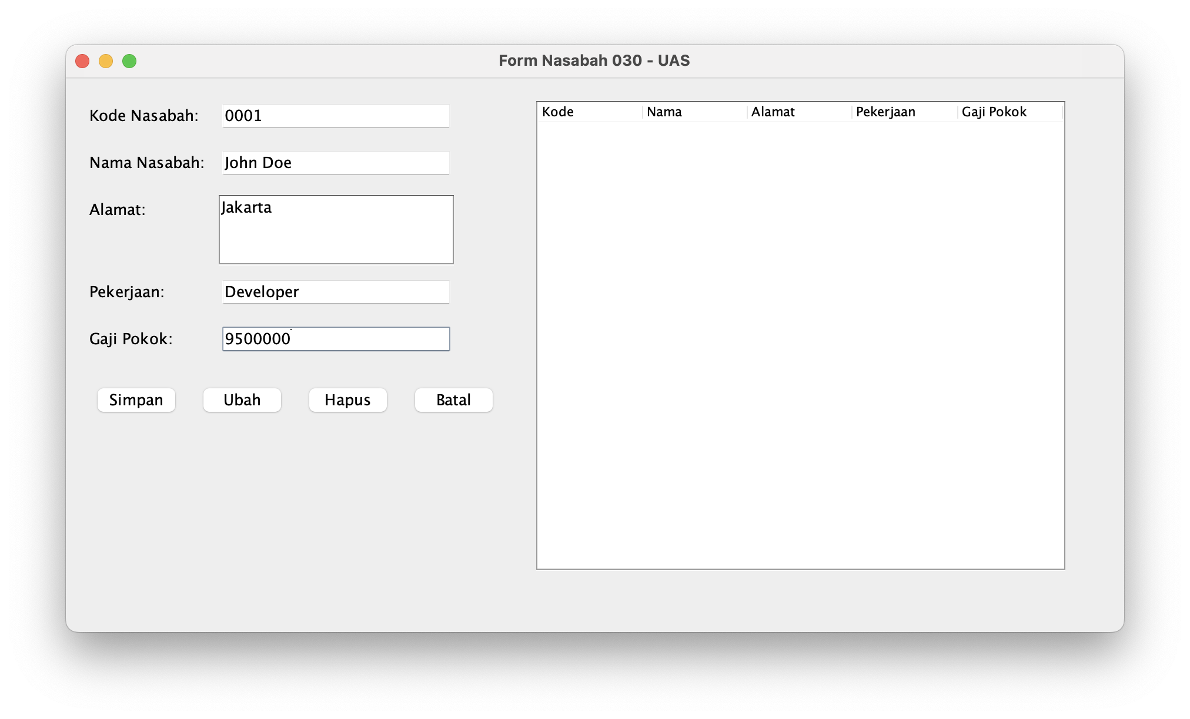

Create Form – Saved Form Modal Confirmation
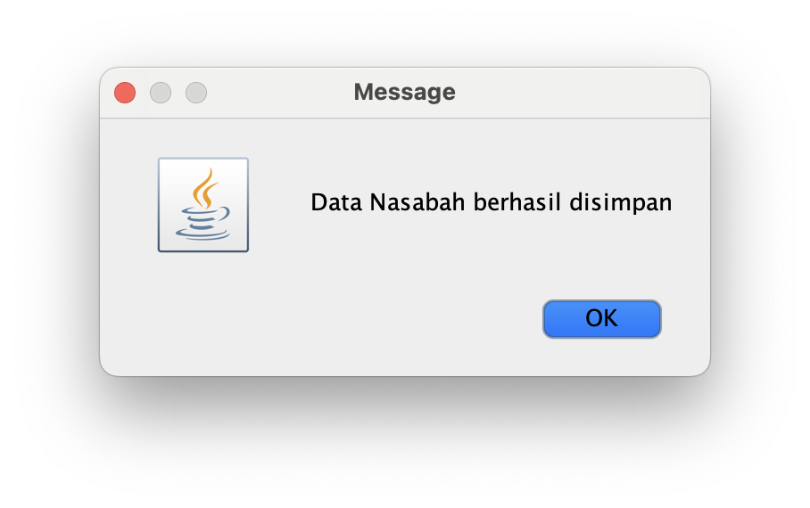

Create Form – Make Sure on Database
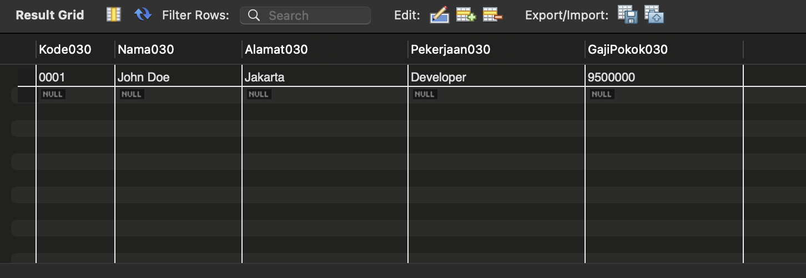

List Form
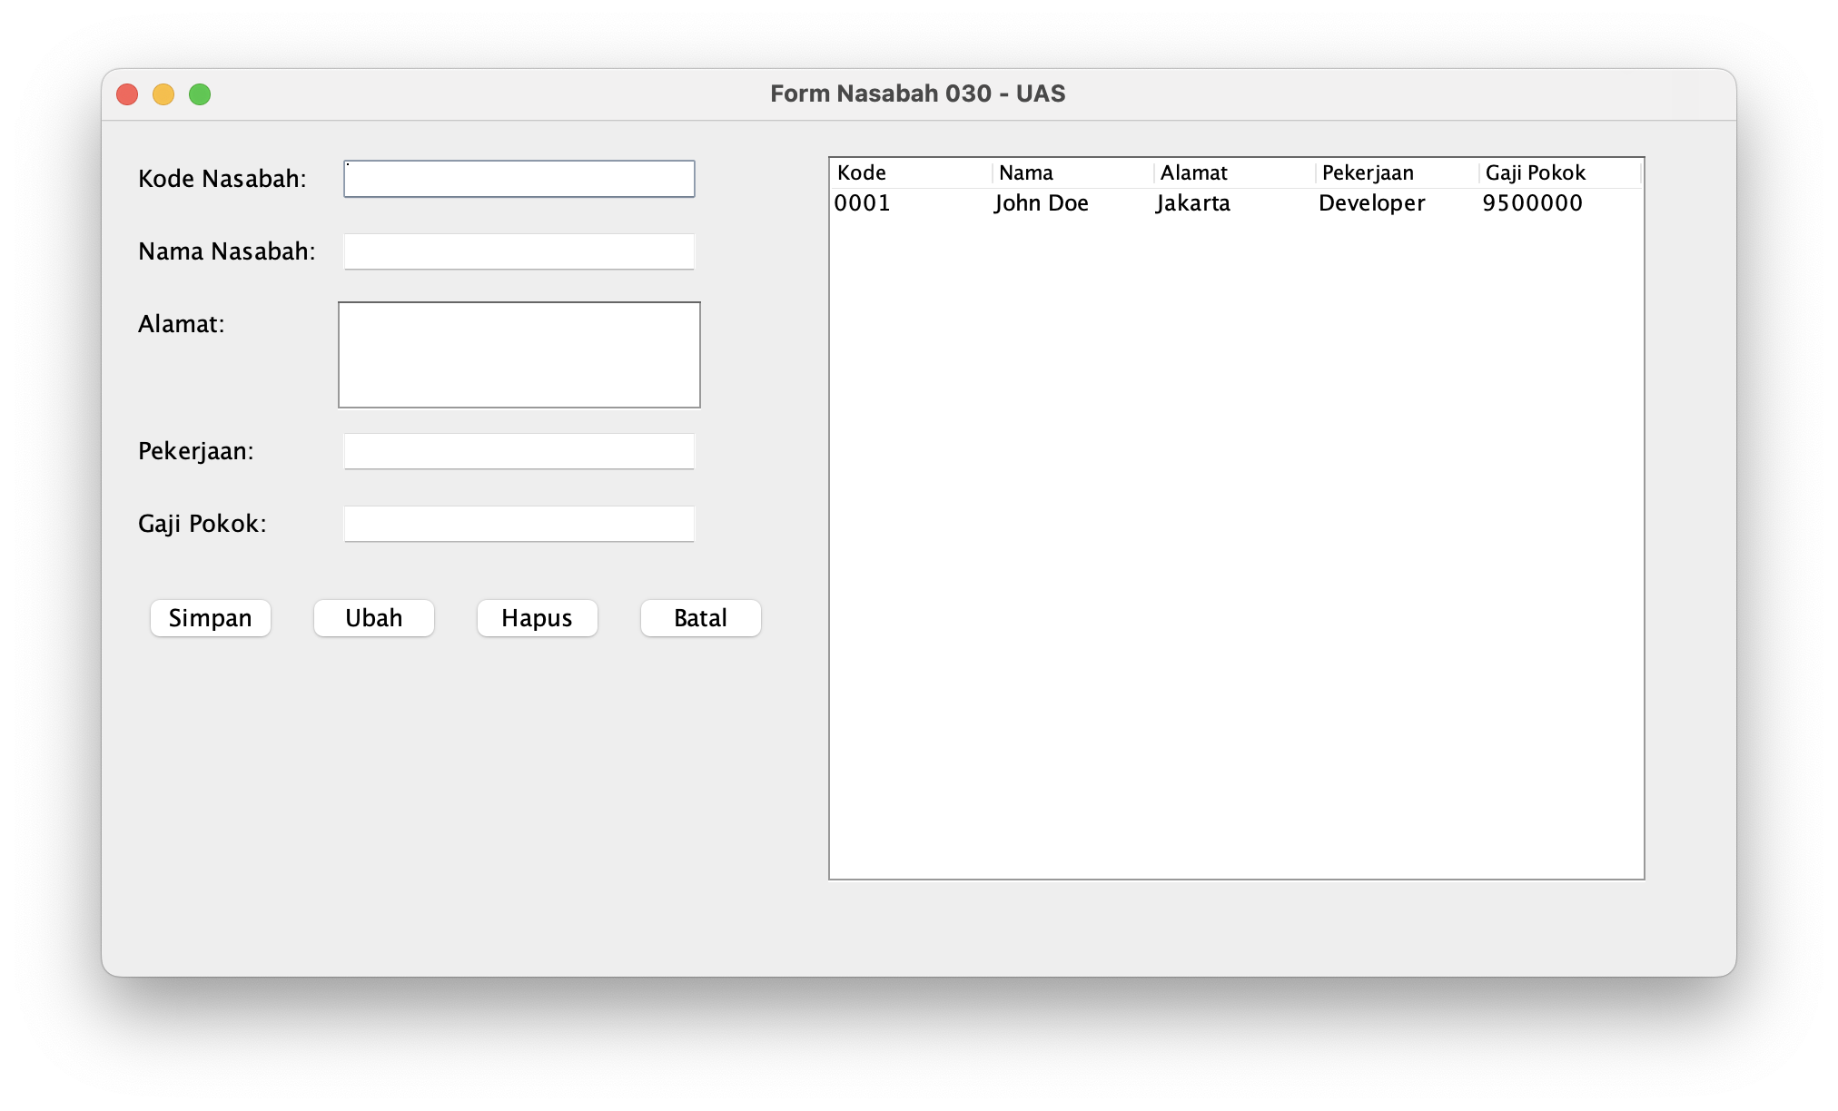

Detail Form
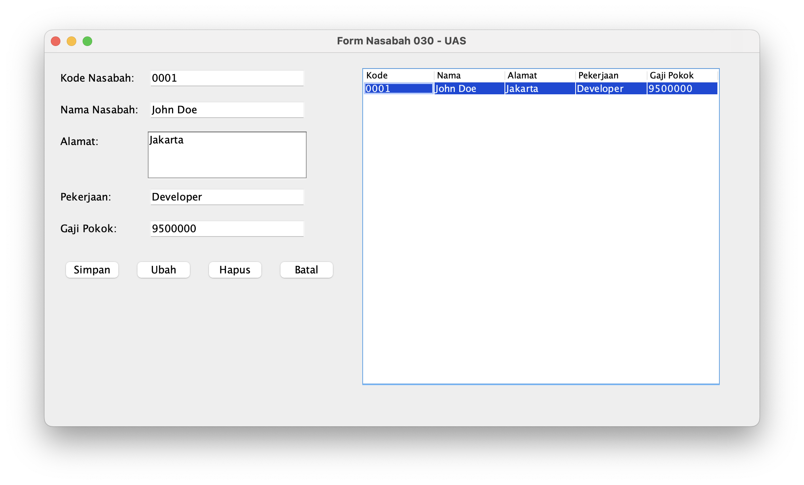

Update Form – Update Data
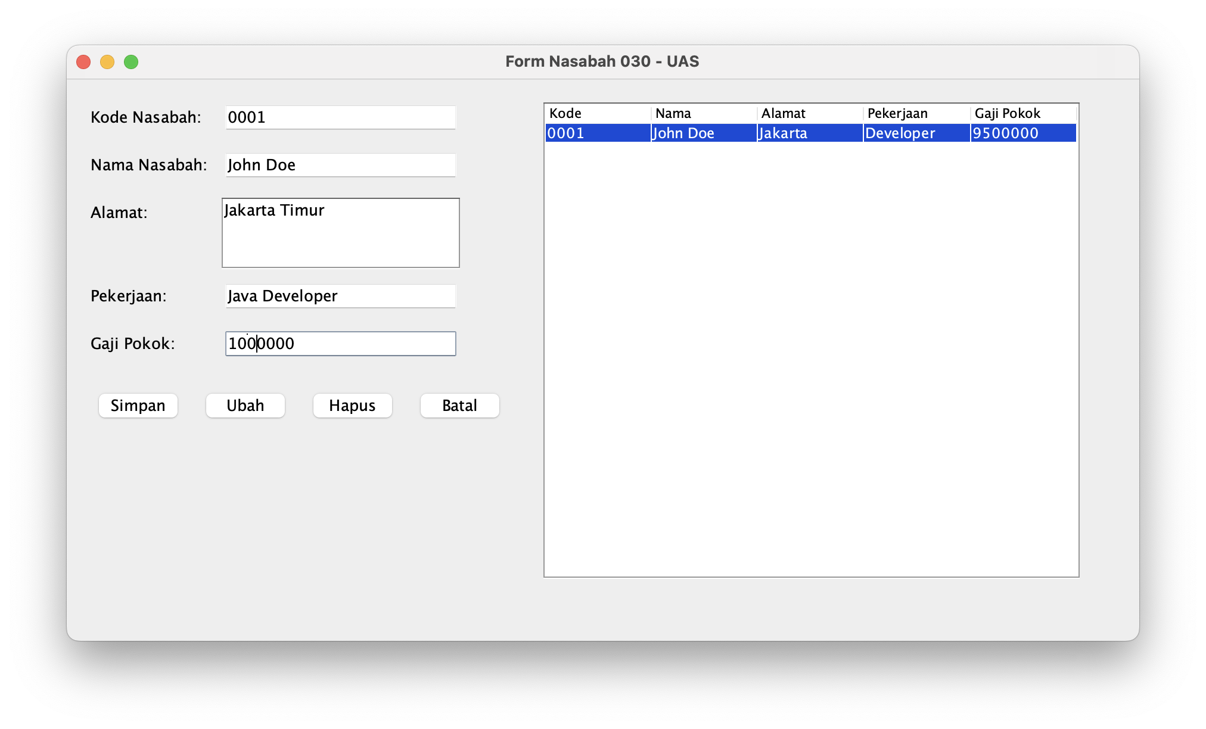

Update Form – Update Form Modal Confirmation
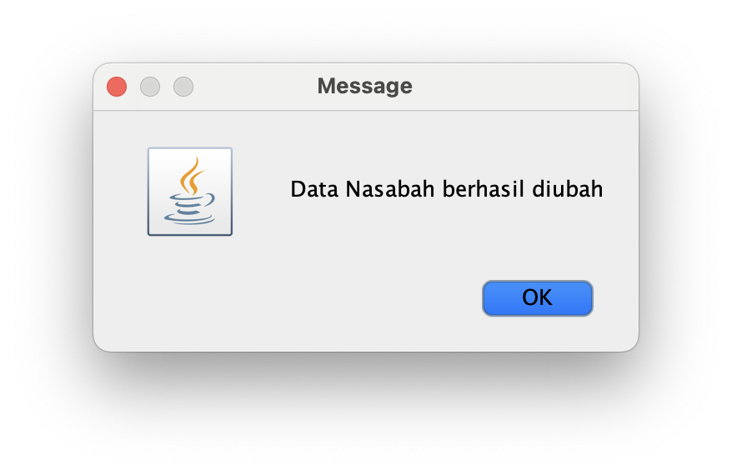

Update Form – List Data After Updated Data
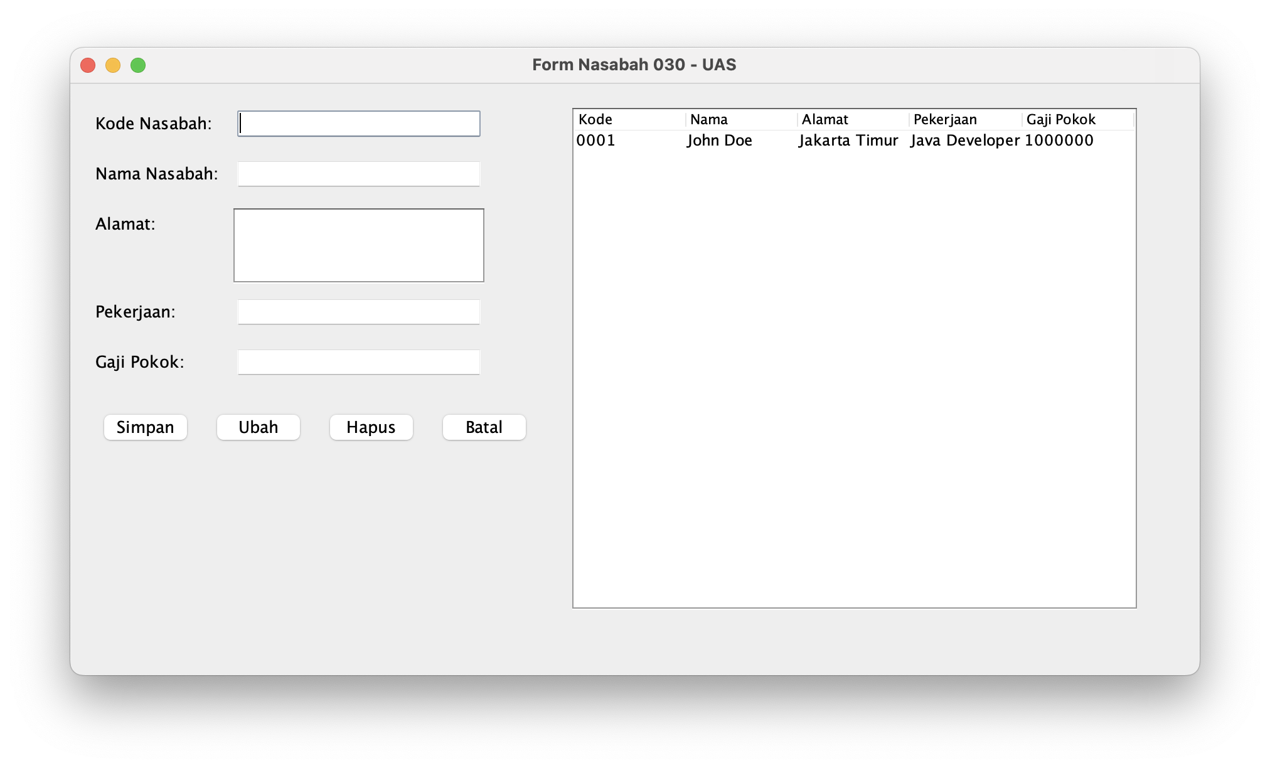

Update Form – Make Sure on Database
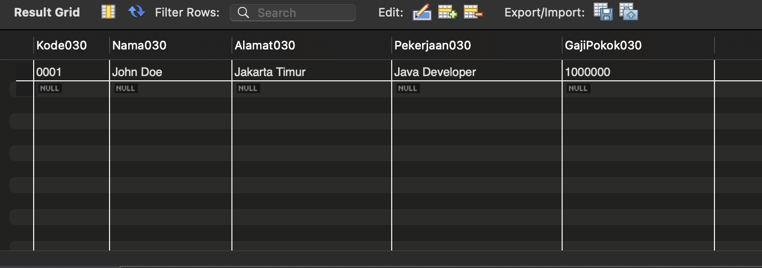

Delete Form – Update Form Modal Confirmation
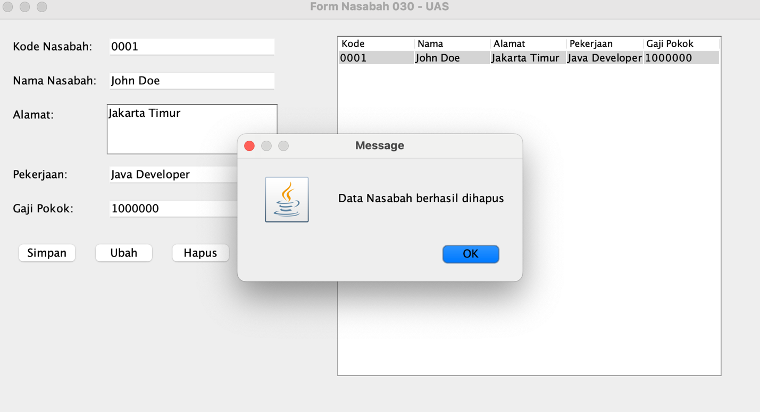

Delete Form – Make Sure on Database
